Journey Through The Bible

**Jonah**

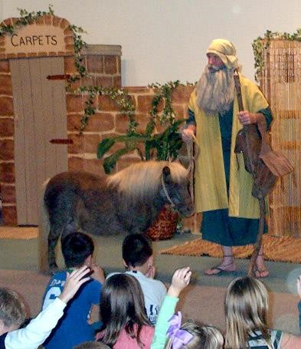

Hello! My name is Jonah, son of Amittai and I am a Prophet. You may already know that a Prophet is a person chosen by God to deliver his message to other people here on earth. Well, let me tell you that being a Prophet can get you into some exciting situations sometimes; I would like to tell you about one of my experiences.

How many of you have heard the story of Jonah and the big fish? Well, I can tell you about that story first hand since it happened to me.

I live in Israel. The country of Assyria is about 500 miles to the east of Israel; the capital city is Nineveh. It is a big city and some say that it would take a man three days to walk around it. A lot of people live in Nineveh, probably about 120,000. Nineveh is a wicked city and one of my country's worst enemies. They worship idols and not my God.

One day God spoke to me and told me to go and preach to the people of Nineveh and to tell them to repent of their wicked ways. Repent means they were sorry of their wicked ways and changes to doing good.

I really didn't like the people of Nineveh and I did not want to go there. I decided that I would run as far away from

Nineveh as I could. So I ran away towards the west to a city by the sea called Joppa. I found a ship going to a place called Tarshish. I bought a ticket and went on board.

We set sail pretty quick and since I was tired, I went down inside the ship, lay down and fell asleep. While the ship was at sea, a great storm came up with very strong winds. The ship was tossed about so much that the sailors thought it was going to sink. They started praying to their idol gods for help. The storm just kept on raging; they started to throw things overboard to lighten the ship's load. It didn't help.

Then they decided that someone on board had done something wrong to bring this storm on them. The Captain woke me up and asked me why I was sleeping and not praying. They all decided that I was the one who caused the storm. They started asking me all kinds of questions, like who are you? Where are you from? What do you do?

I told them that I was a Hebrew and that I feared the Lord, the God of heaven, who made the sea and the dry land. I told them t hat I was running away from my God.

They asked me what could be done to calm the storm. I said, throw me into the sea because I have caused this storm. But they didn't really want to do this. So they worked harder to steer the ship, but couldn't do it.

They finally decided to throw me into the sea.

While I was sinking into the murky water, a huge, big fish came by and swallowed me up. While I was in the belly of the fish, I prayed to my God, thanking him that I had not drowned. After three days the big fish spit me out on the beach and I was safe and sound on dry land once again.

There is a message in this story that we all should leam and remember. First, we cannot run away from God. Second, we should always do the things that He wants us to do to avoid punishment. Third, we should always care for others just like God cared for the wicked people of Nineveh. He wanted to save them even though they were wicked.

I enjoyed telling you my story about the big fish and God's mercy. I hope that you enjoyed it and will remember the lessons we learned.

Scripture reading: **Jonah 1:1-17; 2:1-10**

Memory Verse:

**Psalms 32:7 You are my hiding place; You shall save me from trouble**

What did you learn from this lesson?

☺ Like Naaman, you must do what God tells you to do.

Do you know? **Answer on back page**

**?** **When was Naaman cleansed of his leprosy?**

**? Answer to do you know.**

**● When he obeyed God.** 